Sample Questions

- Give an example outside of computers when you use an interrupt driven method of checking for the completion of an operation.
Setting a timer on an oven – there are numerous other possibilities here.

- Describe how RAID subsystems improve disk performance.
I/O requests are spread out over multiple drives, decreasing queuing delays and increasing the amount of data that can be read/written.

- Why do most system administrators select a RAID 5 disk subsystems over RAID 0, given that RAID 0 is faster than RAID 5?
RAID 5 has redundancy, RAID 0 does not.

- Answer the following questions regarding the PCI bus.

  - What pair of lines are multiplexed together on the PCI bus? (also see part b)
Address and data
  - What other two pair of lines are multiplexed together?
Command and byte enable lines
  - What is the purpose behind the IRDY and TRDY signals?
Indicate that the initiator and target are ready for data transfers
  - What purpose does the FRAME line serve?
Marks the start and end of a transaction

- What is the minimum number of clock cycles that it would take to transfer 64-bytes of data on a 33 MHz, 32-bit PCI bus?
32-bit bus is 4 bytes wide – would take at least 64 bytes / 4 bytes/cycle = 16 cycles to transfer the data
  - How many cycles would it take if the bus operated at 66 MHz?
The same, only the speed is increased – 16 cycles
  - Identify the use of any additional clock cycles needed to transfer the 64-bytes of data as part of a transaction.
Need to send the address and wait for the target to respond

- Each of the following statements about buses has choices shown in italics that can be used to complete the sentence. Circle the word or words that makes the statement true.

  - The address lines of a bus carry the destination or source of the data during a read operation.
source
  - Buses can be clocked faster when they are short or long and narrow or wide.
Short and narrow
  - The width of a bus indicates the number of data or address lines available.
data
  - The PCI bus has which two lines multiplexed together: address and control and data.
Address and data

- Describe the reasoning behind creating a memory hierarchy and why locality of reference is important.
Systems need a lot of memory, but large memories are slow – we use a hierarchy to provide fast memory near the processor, but larger, slower memory down the hierarchy. Locality of reference means that data close together in storage will be accessed close together – such as all variables stored together for a function.

- Referring to the figure below, explain why there is a delay between the address appearing on the bus and the arrival of the data on the third clock cycle.
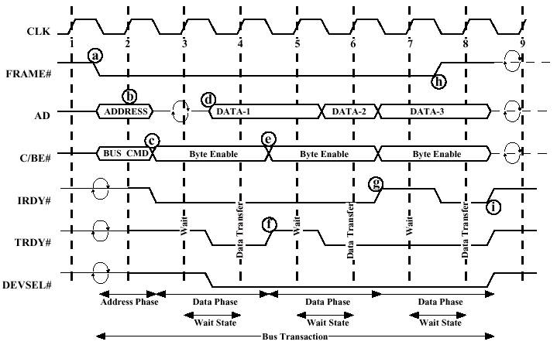
The target needs to decode its address and see that it owns it

- Mark the following statements that are true with respect to processor caches.

  - It is easier to implement a least recently used replacement algorithm on a 2-way set associative cache than a 4-way set associative one.
True – only requires 1 bit to toggle, rather then 2 bits to cycle through
  - A fully associative cache behaves similar to a direct-mapped cache.
false
  - Cache tags are not used with direct-mapped caches.
False – tags are required with all caches
  - Write-back caches require an extra bit, known as the dirty bit.
true
  - Slot numbers are not used with associative caches.
true
  - Bus snooping helps to maintain cache coherency on write-back caches.
False – write back caching does not send the data to memory until the cache is flushed
  - A write-through cache always maintains the same data in cache as that stored in memory.
true

- Mark the following statements that are true with respect to RAID subsystems.

  - Smaller data strips permit a single I/O request to be serviced by more disks than larger strips.
true
  - RAID 5 provides data redundancy by adding XOR data to a single redundant drive.
False – redundant data is spread across multiple drives to prevent a write bottleneck
  - In general, RAID 5 provides faster reads than writes.
True – no redundancy calculation is needed
  - RAID 1 provides data redundancy, but does not increase read or write performance.
False – read access can be improved
  - RAID 3 is good for supporting a large number of random writes to disk.
False – good for sequential accesses

